**PART 1**

1. Type Company's name, then it should display all its details
2. Pie chart of “% of employees laid off”

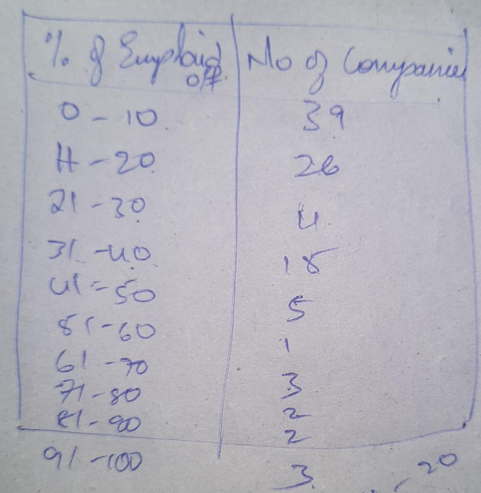

3. Bar graph between number of companies and sector

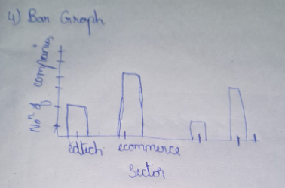

4. Line graph between number of companies and reasons

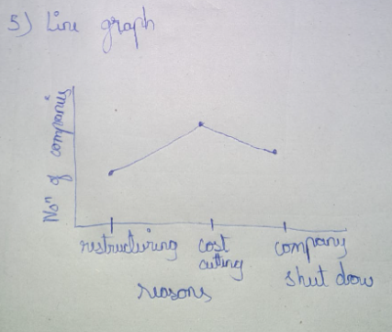

**PART 2**

1. Job Roles:

If we select different skills that we have, it should show us suitable job roles

2. Job Skills:

If we type a skill Name, it should be able to display the required acquisitions

3. Job Risks:

If we type a company name, it should be able to display High/low layoff risks